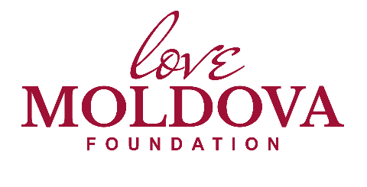
Funding Application Form

All applications will be decided upon by the trustees of Love Moldova Foundation and their decision is final.
All applications will be measured against our Vision, Mission and Values
All applications are to include the following sections and be no more than two pages of A4

- Briefly describe your organisation or mission.

- Give an outline of the project requiring funding – why it is needed, who will benefit and in what way.

- What is your budget for the project – a breakdown of costs, the amount you are requesting, and any money raised so far.

- What is the timescale for the project – when it will start and finish.

- How you plan to measure the success and impact of the project.

- Full contact details of the person responsible for the application (including the full name, postal address and telephone number).

